Project plan template guidance

Use this template to start writing your plan. Remember that it is only a template and can be changed and altered to suit your project. For example, if your project doesn’t involve planting you can delete the section related to planting. Add more space if you need more space to fill in your answers or delete rows if you need less space.

Writing a project plan in not usually something that can be done in a couple of hours. It is expected that you will take several days or sometimes weeks to plan out and write your project plan. You may need to go away and spend time talking to others, investigating costs or seek expert advice.

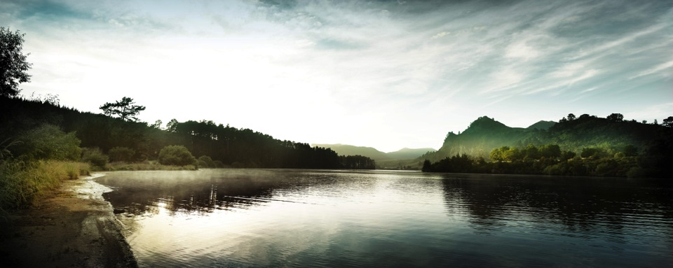
Project plan
Add project title here

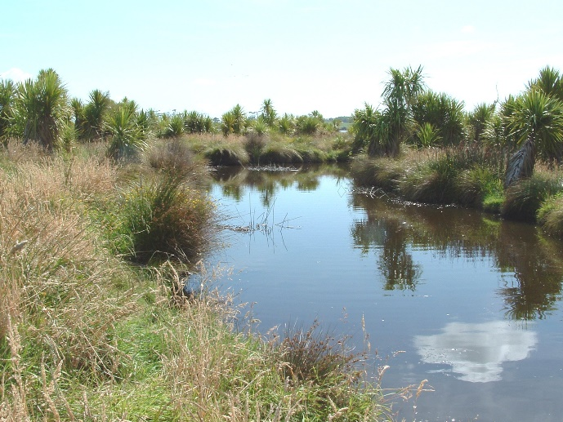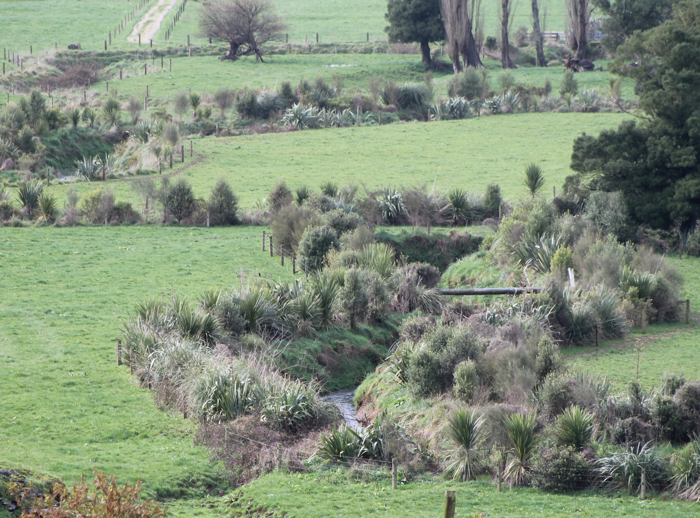
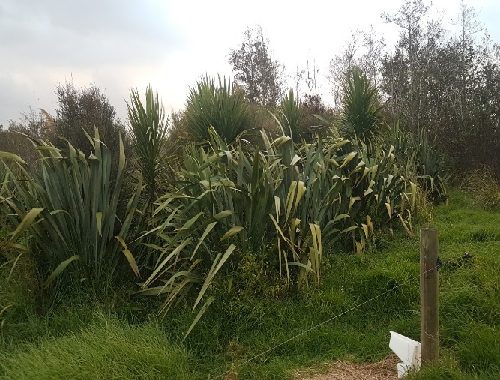
Author:

DATE:

INTRODUCTION

Summary of Issues (describe the issues and reasons why your project is needed)

PROPOSAL – WHAT YOU PLAN TO DO
Vision (what you want the situation to look like in 10 or 20 years time)

Goals - steps towards the Vision (Make sure your goals are SMART - Specific, Measurable, Achievable, Relevant and Timebound e.g. Clear 1 ha of weeds from alongside the stream by April 2020)
-
-
-
-

Tasks required to achieve the goals (what, where, how much, when, who).
Think about the tasks required to achieve each of your goals. Add each task to the table (the grey lines are examples).
Goal no. | Work Required | Estimated Cost | Who will do the work | When
1 | Wananga 1 - Rongoa  Hold a wananga with a minimum of 10 attendees from local Marae on Rongoa | Mare Hirage - $500  Catering ($20 per person)  Facilitator Koha ($200) | Project manager to co-ordinate the event and participants.  Facilitator to run the wananga | August 2022
2 | Native planting  Plant 1000 native plants in accordance with the planting plan | Native plant purchase - $4 per plant = $4,000  Native planting labour - $1 per plant = $1,000 | Kaitiaki group from XX Marae | September 2022

For each task listed in the previous table, add a title below and provide more detail about each task e.g. what the task involves, where it will take place, who will be involved, who will lead it, when it will be undertaken, any other tasks that need to happen first.
Wananga 1

Native Planting

Annual work plan
Below is an example of how you might plan your annual work.
Year 1 - 2019
Activity | Jan | Feb | Mar | Apr | May | Jun | Jul | Aug | Sep | Oct | Nov | Dec
Wananga 1 |  |  |  |  |  |  |  | √
Wetland planting |  |  |  |  |  |  |  |  | √

Costs (Use a separate spreadsheet to itemise and calculate your project costs. It useful to do this for each year of the project).

PROJECT RISKS (assuming you get the funding you are looking for what could happen that could risk your project being unsuccessful)
Risk (What could happen) | Consequence (What would this mean for your project) | Management plan (What are you doing to help ensure this doesn’t happen)

